**PYTHON ASSESSMENT-1**

Q1) Explain Pandas for Data Processing & execute Reading CSV Data using Pandas  
&Read Data from CSV Files to Pandas Dataframes  
&Filter Data in Pandas Dataframe using query.

Pandas For Data Processing:

Pandas is a python library which is used for data manipulating, analyzing data. It helps in coverting the raw data into structured data to help the user understand the data.

Some of the key features are :

1. **Dataframe:** The Dataframe is a 2-Dimensionsl data structure which defines a table which consists of rows and columns where each column has some different data types.
2. **Data Manipulation:** Pandas which provides a different varieties of functions for manipulating the tasks , filtering, grouping, joining etc.
3. **Series:** In this series, the pandas offers a data structure which is capable for holding any datatype
4. **Input/Output:** The pandas supports in reading and writing the data from files , databases , sheets etc and they also integrate with data sources.

Here is the following CSV File which consists of data and we have named the CSV File as “assessment.csv“

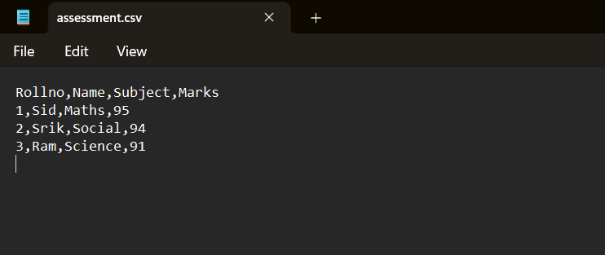

**Reading CSV Data using Pandas:**

We will be using ‘read_csv()’ function from the pandas library to read the data from a csv file which consists of data and reading that csv file into Framework.

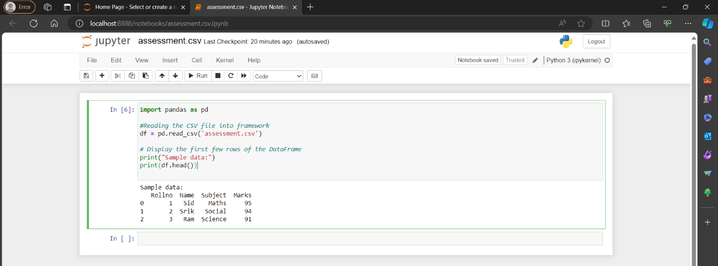

**Read Data From CSV file to Pandas Dataframes:**

We will be using the ‘pd.read_csv()’ function which helps in reading data from CSV file into Pandas Dataframes.

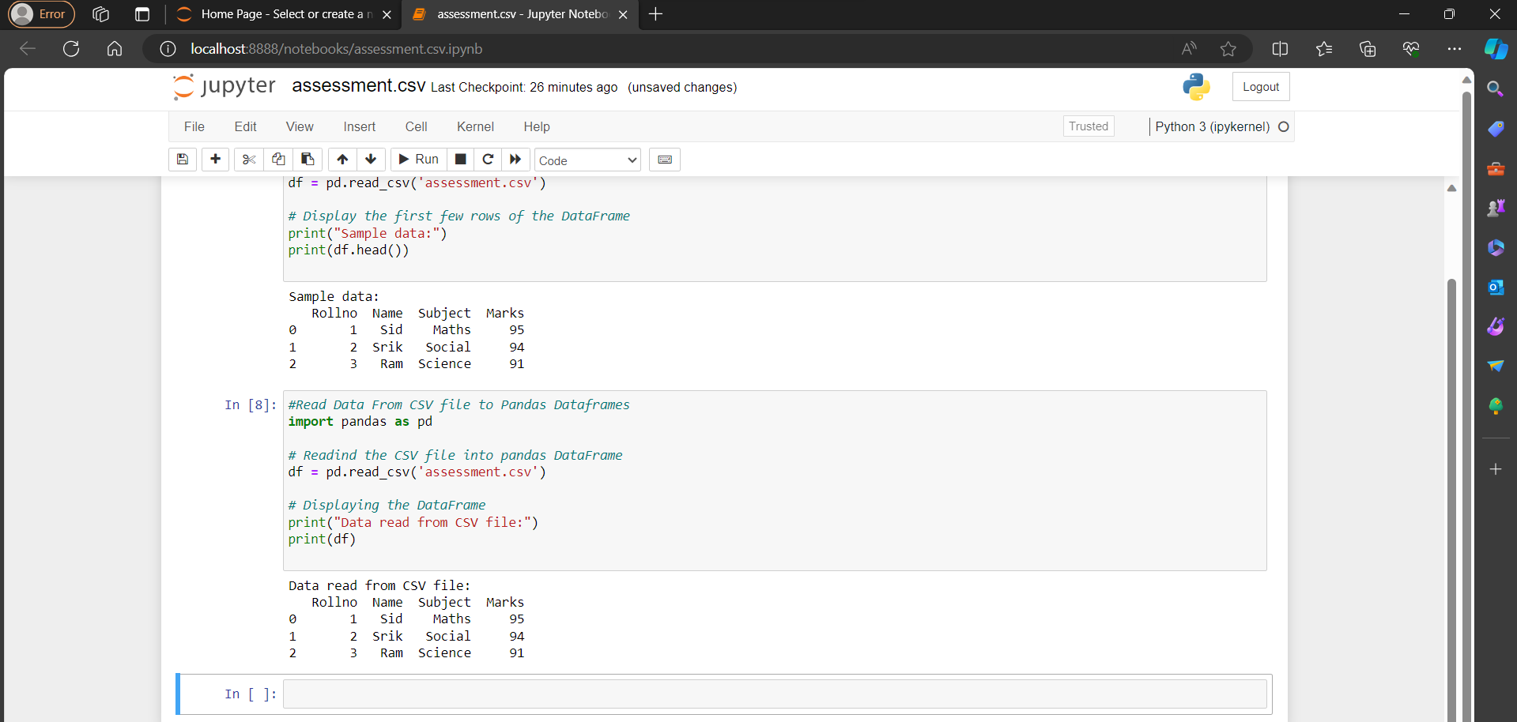

**Filtering data in Pandas Dataframe using Query:**

For Filtering the data we will be using *‘*query()’ method which provides a simple way to select the required information based on our conditions mentioned**.**

